PROGRAM 6: VACUUM CLEANER PROBLEM
Aim
The aim of this experiment is to implement the Vacuum Cleaner Problem using a Simple Reflex Agent.
Objective
To clean all dirty rooms using a simple vacuum cleaner agent.
Algorithm
Algorithm: VacuumCleaner()
Step 1: Start.
Step 2: Initialize the environment with two rooms (A and B).
Step 3: Place the vacuum cleaner in the initial room.
Step 4: Check whether the current room is Dirty or Clean.
Step 5: If the room is Dirty,
Clean the room.
Step 6: Otherwise,
Move to the next room.
Step 7: Repeat Steps 4 to 6 until all rooms become Clean.
Step 8: Display the final status of all rooms.
Step 9: Stop.
Source Code
rooms = {
'A': 'Dirty',
'B': 'Dirty'
}
location = 'A'
while True:
print("Vacuum is in Room", location)
if rooms[location] == 'Dirty':
print("Cleaning Room", location)
rooms[location] = 'Clean'
else:
print("Room", location, "is already Clean")
if location == 'A':
location = 'B'
else:
location = 'A'
if rooms['A'] == 'Clean' and rooms['B'] == 'Clean':
break
print("\nFinal Room Status")
print(rooms)
print("\nGoal Achieved: All Rooms are Clean")
Flowchart
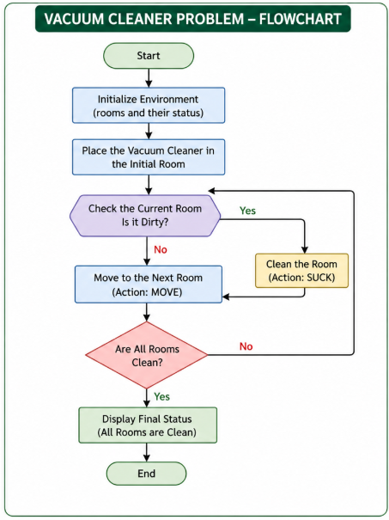

OUTPUT:
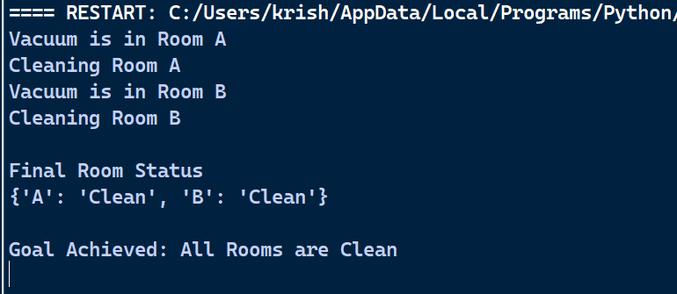
Result
Thus, the Python program for the Vacuum Cleaner Problem was executed successfully.

